**TITLE OF THE RESEARCH/STUDY (SHOULD BE IN ENGLISH; CONCISE AND INFORMATIVE)**

**First Author1*, Second Author2, Third Author2,3, Fourth Author1,3, etc.**

1Department/Unit, Institution, City – COUNTRY

2Department/Unit, Institution, City – COUNTRY

3Department/Unit, Institution, City – COUNTRY

*corresponding author, contact: (add postal and email address of the corresponding author)

**ABSTRACT**

(max 300 words)

**Background:** the context and purpose of the study.

**Methods:** how the study was performed and statistical tests used.

**Results:** the highlights of main findings.

**Conclusion:** brief summary and potential implications.

**Keywords:** please write 3-7 keywords (each keywords max. 5-words) representing the main contents to this study

**-------------end title and abstract page, start of manuscript body---------------**

**INTRODUCTION**

The introduction should discuss the background of the research, the rationale and the research questions and/or aims. In this section, the current evidence on the topic should be discussed to subsequently be related to the research gap which would be addressed by the research.

**METHODS**

This section should include the research design applied, context (i.e., institutions, regions, organizations, time, etc.), subject and sampling, data collection (i.e., process and tools), data analysis and the steps of the research. Please provide a clear description of all processes, interventions and comparisons. Research design should be stated clearly (i.e., quantitative, qualitative, mixed-methods, reviews, etc.). A thorough explanation on the type of statistical analysis used, including a power calculation should be described if appropriate.

**RESULTS**

This section should include the findings of the study including, if appropriate, results of statistical analysis which must be included either in the text or as tables and figures.

Table 1. Example of table presentation

|  |  |  |  |
| --- | --- | --- | --- |
| **Batch** | **Comparison** | **Mean Difference** | **p Value** |
| **2014** | SNMPTN-SBMPTN | 0.32955 | 0.001 |
| SNMPTN-JNS | 0.72951 | <0.001 |
| SNMPTN-International | -0.06713 | 1.000 |
| **2015** | SNMPTN-SBMPTN | 0.67841 | <0.001 |
| SNMPTN-JNS | 0.39204 | 0.032 |
| SNMPTN-International | -0.15974 | 1.000 |
| **2016** | SNMPTN-SBMPTN | 1.41199 | <0.001 |
| SNMPTN-JNS | 0.87287 | <.001 |
| SNMPTN-International | 0.57819 | 0.007 |

*use only horizontal lines*

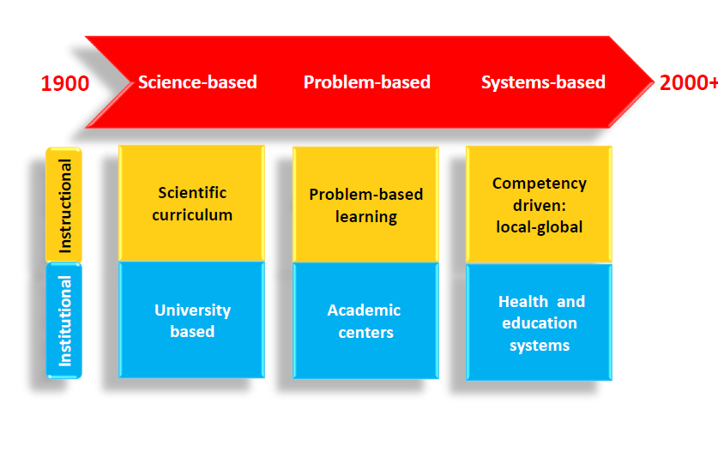

Figure 1. Example of figure/chart/flowchart presentation

This is an example of adding an interview or focus group discussion transcript into the manuscript in qualitative research:

*“This is an example of adding an interview or focus group discussion transcript into the manuscript in qualitative research. Please mind that it should be arranged this way to ensure that the transcript is not misunderstood as an argument”* (Code)

The transcript should be written as an indented paragraph, italic may be coded.

**DISCUSSION**

This section should discuss the implications of the findings in context of existing research and highlight limitations of the study.

**CONCLUSIONS**

Authors are expected to state clearly the main conclusions and provide an explanation of the importance and relevance of the study reported.

**LIST OF ABBREVIATIONS**

ABB1: Abbreviation Number One

ABB2 : Abbreviation Number Two

ABB3: Abbreviation Number Three

**-------------end of manuscript body, start of declarations section---------------**

**ETHICS APPROVAL AND CONSENT TO PARTICIPATE**

Manuscripts reporting studies involving human participants, human data or human tissue must:

* include a statement on ethics approval and consent (even where the need for approval was waived)
* include the name of the ethics committee that approved the study and the committee’s reference number if appropriate

Studies involving animals must include a statement on ethics approval and for experimental studies involving client-owned animals, authors must also include a statement on informed consent from the client or owner.

**COMPETING INTEREST**

Authors should declare any competing or possible conflict of interest regarding to the article. Available funding donors should also be declared. If there is no competing interest to this study, please write:

“The authors declare that there are no competing interests related to the study”

**ACKNOWLEDGEMENTS**

Authors might express their acknowledgement to ones who are supporting this study, including funding and other kinds or support. This section is optional.

**AUTHORS’ CONTRIBUTION**

In this section, authors’ details and their contribution toward the manuscript and research should be described. Example:

*Andika Susina* – developing research proposal, collecting data, data analysis, and publication manuscript.

*Berlarminus* – developing research proposal and collecting data.

*Chicka Ardelia* – developing research proposal and collecting data.

*Dadang Suparman* – data analysis and publication manuscript.

**-------------end of declarations section, start of bibliography---------------**

**REFERENCE LIST**

The amount of literature cited should be sound but reasonable and it is expected that 70% of them are current literature of the last 10 years. Please use BMC Med Educ Vancouver style:

*In-text Citation:*

Use bracketed-numbering system, that should be written before commas [1], full-stops [2,3]. The in-text citation should be written before semicolons [4-6]; or colons [1,3,5-9]: to adhere to citation guideline.

*Reference List:*

Some examples:

**Example reference style:**

*Article within a journal*

Smith JJ. The world of science. Am J Sci. 1999;36:234-5.

*Article within a journal (no page numbers)*

Rohrmann S, Overvad K, Bueno-de-Mesquita HB, Jakobsen MU, Egeberg R, Tjønneland A, et al. Meat consumption and mortality - results from the European Prospective Investigation into Cancer and Nutrition. BMC Medicine. 2013;11:63.

*Article within a journal by DOI*

Slifka MK, Whitton JL. Clinical implications of dysregulated cytokine production. Dig J Mol Med. 2000; doi:10.1007/s801090000086.

*Article within a journal supplement*

Frumin AM, Nussbaum J, Esposito M. Functional asplenia: demonstration of splenic activity by bone marrow scan. Blood 1979;59 Suppl 1:26-32.

*Book chapter, or an article within a book*

Wyllie AH, Kerr JFR, Currie AR. Cell death: the significance of apoptosis. In: Bourne GH, Danielli JF, Jeon KW, editors. International review of cytology. London: Academic; 1980. p. 251-306.

*OnlineFirst chapter in a series (without a volume designation but with a DOI)*

Saito Y, Hyuga H. Rate equation approaches to amplification of enantiomeric excess and chiral symmetry breaking. Top Curr Chem. 2007. doi:10.1007/128_2006_108.

*Complete book, authored*

Blenkinsopp A, Paxton P. Symptoms in the pharmacy: a guide to the management of common illness. 3rd ed. Oxford: Blackwell Science; 1998.

*Online document*

Doe J. Title of subordinate document. In: The dictionary of substances and their effects. Royal Society of Chemistry. 1999. http://www.rsc.org/dose/title of subordinate document. Accessed 15 Jan 1999.

*Online database*

Healthwise Knowledgebase. US Pharmacopeia, Rockville. 1998. http://www.healthwise.org. Accessed 21 Sept 1998.

*Supplementary material/private homepage*

Doe J. Title of supplementary material. 2000. http://www.privatehomepage.com. Accessed 22 Feb 2000.

*University site*

Doe, J: Title of preprint. http://www.uni-heidelberg.de/mydata.html (1999). Accessed 25 Dec 1999.

*FTP site*

Doe, J: Trivial HTTP, RFC2169. ftp://ftp.isi.edu/in-notes/rfc2169.txt (1999). Accessed 12 Nov 1999.

*Organization site*

ISSN International Centre: The ISSN register. http://www.issn.org (2006). Accessed 20 Feb 2007.

*Dataset with persistent identifier*

Zheng L-Y, Guo X-S, He B, Sun L-J, Peng Y, Dong S-S, et al. Genome data from sweet and grain sorghum (Sorghum bicolor). GigaScience Database. 2011. <http://dx.doi.org/10.5524/100012>.